worssBasic

Use External Tools and Gnu Core Tools to enhance your shell skills. Compose them using pipes and filters.

1. Unzip (using the terminal) our ​titanic.zip​ file to ​titanic

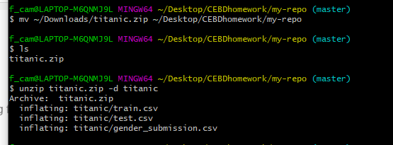

1. Provide the shape/dimensions of the file ​train.csv​?

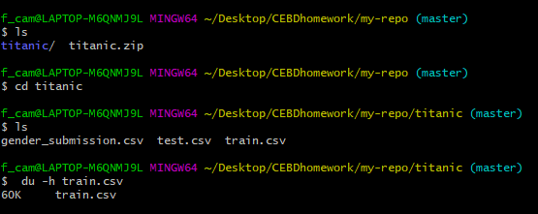

1. List the first 5 rows of the file. Now list the last 5.

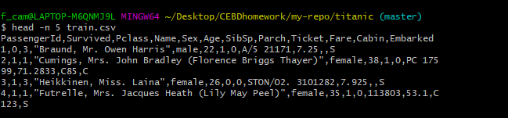

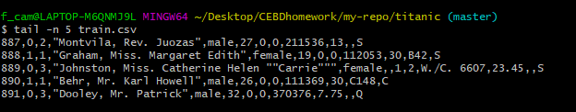

1. Print this file in your screen using ​cat​ now use the ​less​ command

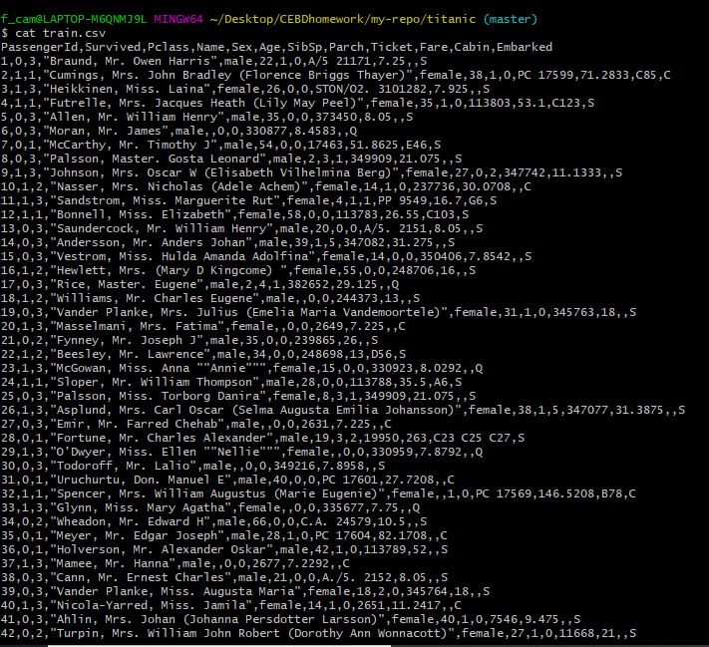

Less

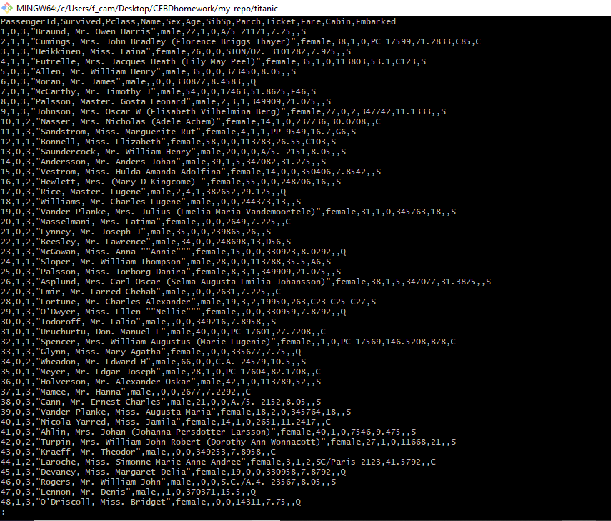

1. Can you print only the names of all people in the file?

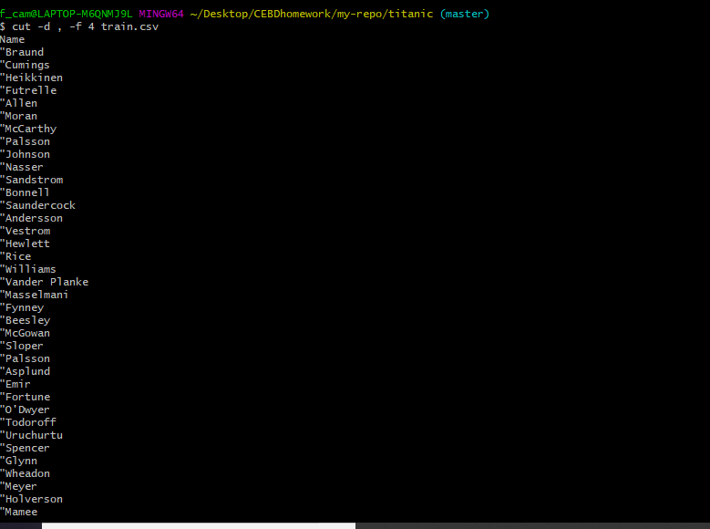

1. Print this file last 5 lines save the output to train_tail.csv

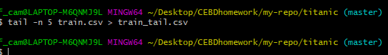

7. Print only the lines 3 to 5 of the file?

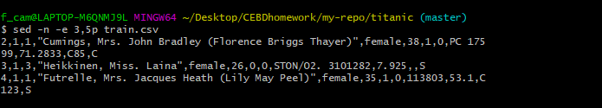

8. Can you explain the command ​du -a . | sort -n -r | head -n 20​ and why would you use it?

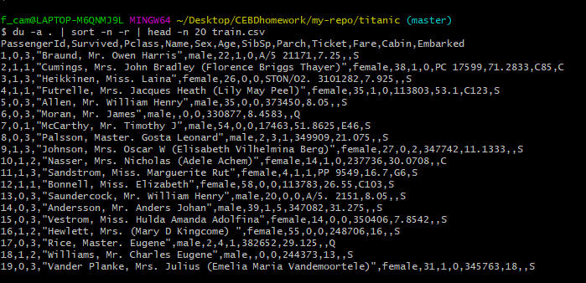

write counts for all files, not just directories, shows the 20 first rows while it sort it by number. Could be used to find some specific information inside a file.

9. Split the train.csv file in multiple files with 20 lines each.

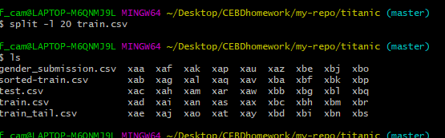

Write loops to iterate over lists

1. Download the ​ultratrail-du-montblanc.zip​ file from Slack and unzip it to /Users/<myusername>/ultratrail

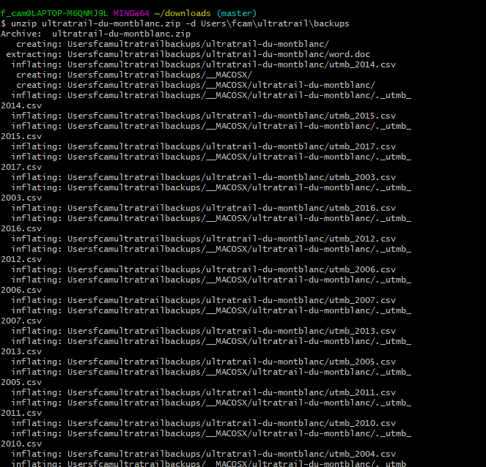

1. Write a loop that prints the name, dimension and first 2 lines for each of the ​.csv files.

